**EXPERMENT 04-WORKING WITH DATASET**

**(1)WEEKLY TEMPERATURE**

import pandas as pd

df = pd.read_csv('temperature.csv')

df = df[df['AvgTemperature'] != -99]

df['Date'] = pd.to_datetime(df[['Year', 'Month', 'Day']], errors='coerce')

df = df.dropna(subset=['Date'])

df['Month'] = df['Date'].dt.month_name()

grouped = df.groupby(['City', 'Month'])['AvgTemperature'].sum().reset_index()

pivot_table = grouped.pivot(index='City', columns='Month', values='AvgTemperature').fillna(0)

pivot_table['Total'] = pivot_table.sum(axis=1)

print("Month-wise Temperature Summary:")

print(pivot_table)

max_city = pivot_table['Total'].idxmax()

max_temp = pivot_table['Total'].max()

print(f"\nCity with highest total temperature: {max_city} ({max_temp:.2f}°F)")

**OUTPUT:**

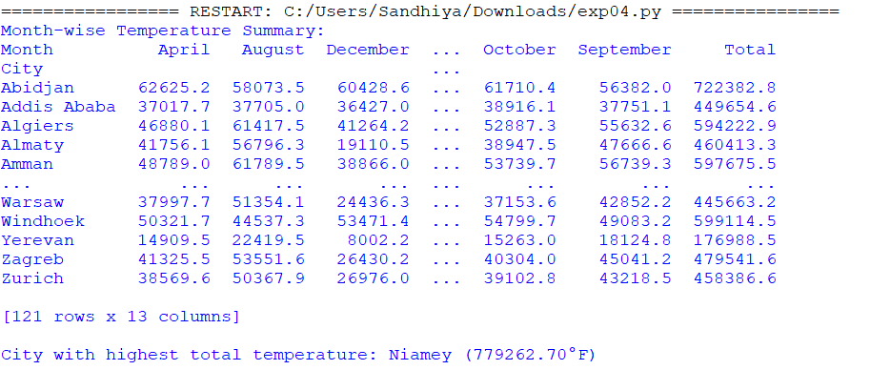

**(2)EMPLOYEE DATASET:**

import pandas as pd

df = pd.read_csv("corporate_work_hours_productivity.csv")

df.columns = df.columns.str.strip()

df = df.dropna(subset=['Department', 'Monthly_Hours_Worked'])

df['Monthly_Hours_Worked'] = pd.to_numeric(df['Monthly_Hours_Worked'], errors='coerce')

df = df.dropna(subset=['Monthly_Hours_Worked'])

dept_hours = df.groupby('Department')['Monthly_Hours_Worked'].sum().reset_index()

pivot_table = dept_hours.pivot_table(values='Monthly_Hours_Worked', index='Department')

max_dept = pivot_table['Monthly_Hours_Worked'].idxmax()

max_hours = pivot_table['Monthly_Hours_Worked'].max()

print("\n📊 Department-wise Total Monthly Working Hours Summary:\n")

print(pivot_table)

print(f"\n🏆 Highest Total Working Hours:\n{max_dept} → {max_hours:.2f} hours")

**OUTPUT:**

